[Project Name]

**To put in a client name select all (ctrl A) then f9Code Star Academy – Kaopiz Software**

**Automation Test Plan**

**Created by: Hoan Tran**

**Version: 1.0**

**December, 01st , 2022**

**Table of Contents**

1. INTRODUCTION 3

2. TEST OBJECTIVES 3

3. TEST STRATEGY 3

*3.1.* *Scope of Testing* 3

3.1.1. In scope testing 3

3.1.2. Out of scope testing 3

*3.2.* *Test Levels and Test Types* 4

*3.2.1.* *Test levels* 4

*3.2.2.* *Test types* 4

*3.3.* *Risks* 5

4. TEST CRITERIA 5

*4.1.* *Entry Criteria* 5

*4.2.* *Suspension Criteria* 6

*4.3.* *Exit Criteria* 6

5. RESOURCE PLANNING 6

*5.1.* *System resource* 6

*5.2.* *Test Resource* 6

6. SCHEDULE AND ESTIMATION 7

7. TEST DELIVERABLE 7

8. AUTOMATION TESTING TOOL AND STRATEGY 9

*8.1.* *Testing process* 9

*8.2.* *Automation strategy* 9

*8.3.* *Automation testing framework* 9

9. LIFECYCLE OF BUG AND RISK 10

1. **INTRODUCTION**

The purpose of the project is to build the system that *[project description]*.

The Test Plan determine the scopes, objectives and risk of testing. Defining the overall test approach, the overall framework, enviroment that will support test activities, resolution for risk and contingency, test criteria, timeline and resource planning.

Build automation test scripts which using for regression test phase.

1. **TEST OBJECTIVES**

* Ensure that system functionality works as expected without any critical, high bugs
* Ensure that the response time when using system meets expectation
* Ensure that the integration between modules and systems work as expectation

1. **TEST STRATEGY**
   1. *Scope of Testing* 
      1. *In scope testing*

In scope items will be system testing as usability of bellow features.

The following is the list features to be tested in this project:

|  |  |  |
| --- | --- | --- |
| No. | UserStory/Function | Degree of complex |
| 1 | Bếp từ – Lọc theo giá | 1 |
| 2 | |  | | --- | |  |  |  | | --- | | **Máy rửa chén bát** – Hiển thị danh sách sản phẩm | | 1 |
| 3 | |  | | --- | |  |  |  | | --- | | **Máy rửa chén bát** – Lọc sản phẩm theo khoảng giá (ví dụ: 3–5 triệu, >15 triệu…) | | 1 |
| 4 | **Máy rửa chén bát** – Lọc theo hãng sản xuất (Bosch, Kaff, Sevilla, Siemens,...) | 2 |
| 5 | **Máy rửa chén bát** – Lọc theo xuất xứ (England, Singapore, Germany...) | 1 |
| 6 | |  | | --- | |  |  |  | | --- | | **Máy rửa chén bát** – Lọc theo kích thước (600mm, 700mm...) | | 2 |
| 7 | |  | | --- | |  |  |  | | --- | | **Máy rửa chén bát** – Nhấn vào sản phẩm để hiện Mô tả sản phẩm | | 1 |
| 8 | |  | | --- | |  |  |  | | --- | | **Máy rửa chén bát** – Hiển thị các tag phân loại (phổ biến, giá thấp, giá cao...) | | 2 |
| 9 | **Máy rửa chén bát** – Mua trả góp | 2 |
| 10 | |  | | --- | |  |  |  | | --- | | **Giao diện** – Hiển thị hình ảnh banner quảng cáo | | 1 |
| 11 | **Trang sản phẩm** – Nút “MUA NGAY” | 2 |
| 12 | **Máy rửa chén bát** – Mua ngay |  |
| 13 | **Máy rửa chén bát** – KHẢO SÁT – TƯ VẤN LẮP ĐẶT TẠI NHÀ | 2 |
| 14 | **Trang sản phẩm** – Nhập số điện thoại nhận khuyến mãi và nhấn “Đăng ký” | 2 |

Degree: 1 – Complex, 2 – Medium, 3 – Low

* + 1. *Out of scope testing*

There are some out of scope items:

* Database test
* Mobile test
* Performance test
* Security test
* API test
  1. *Test Levels and Test Types*
     1. *Test levels*

|  |  |  |  |  |
| --- | --- | --- | --- | --- |
| **No.** | **Test level** | **Method** | **People in charge** | **Note** |
| 1 | Integration test | Manual/Automation | Tester | * Testing the integration of systems and packages; testing interfaces to external organizations * Test to find defects in the interfaces and in the interactions between integrated components or systems |
| 2 | System test | Manual/Automation | Tester | Verify that the whole system meets with requirements |
| 3 | User acceptance test | Manual/Automation | Client | Client test the system to make sure that the system is met the requirement. To make sure the useablitiy, maintanceability, reliablity. |

* + 1. *Test types*

|  |  |  |  |  |
| --- | --- | --- | --- | --- |
| **No.** | **Test type** | **Method** | **People in charge** | **Notes** |
| 1 | Review requirement (static testing) | Manual | Tester | To verify the correction and level of detail of User Story |
| 2 | Review code | Automated/Manual | Dev team | Self-review, Peer Review |
| 3 | Functional testing (dynamic testing) | Automated/Manual | Tester/Dev team | Verify that the system meets functional requirement |
| 4 | Non-functional testing | Manual | Tester | Performance test, API test, Security test |
| 5 | Re-testing | Manual | Tester/Dev team | Testing after fixing bug to confirm the bug is removed |

* 1. *Testing risks*

|  |  |  |
| --- | --- | --- |
| **No.** | **Risk** | **Mitigation** |
| 1 | Requirement contains a lot of technical related to encryption and module communication, not to mention a huge amount of distributed actor, leads tester to difficult to design test cases | * Testers need to review user story/requirement before writing test cases (usually the first 2 days of each Sprint) * Improve communication in the team * Peer review testcase |
| 2 | Tập trung list ra các risks ảnh hưởng tới việc testing: môi trường test bị lỗi trong 1 số TH cần khôi phục lại để có thể test tiếp được, số lượng người dùng hệ thống cao hơn dự kiến | * Lập kế hoạch và nguồn lực phục hồi môi trường * Làm load test, stress test để đảm bảo độ tải của hệ thống |
| 3 | Project schedule is tight and short, it may be hard to complete testing on time | * Set priority for test activities: focus testing on the core features that contains many critical bugs * Writing test checklist instead of test cases step by step if not enough time |
| 4 | System is complex so deployment may be has potential issue | In sprint planning, team need to clarify deployment schedule |
| 5 | . **Bộ lọc giá không hoạt động chính xác (ví dụ: lọc sai khoảng giá)** | Tạo test script kiểm tra từng mức giá |
| 6 | Giá sản phẩm hiển thị không đồng nhất (giá cũ, giá mới, % giảm sai) | Kiểm tra định dạng và tính toán hợp lệ giảm giá  So sánh với dữ liệu backend (nếu có API) |
| 7 | **Dữ liệu hãng (Bosch, Feuer, Sevilla,...) bị thiếu hoặc hiển thị sai sản phẩm** | So sánh text sản phẩm, alt hình ảnh với tên hãng  Tách riêng testcase kiểm thử lọc theo hang |
| 8 | Nút “Mua ngay” / “Mua trả góp” không hoạt động do thay đổi giao diện hoặc sự kiện JavaScript | Ghi log khi click + kiểm tra có mở popup/điều hướng đúng |
| 9 | Tốc độ load trang máy rửa bát chậm, gây timeout khi automation test chạy | Thiết lập timeout phù hợp, kiểm tra tốc độ mạng |
| 10 | Thất bại khi đăng ký mua do không validate lỗi nhập liệu | Tạo test nhập dữ liệu sai để kiểm tra báo lỗi |
| 11 | Logo hãng không click được hoặc không phản hồi | Dùng WebDriverWait để kiểm tra khả năng click trước khi thao tác |

1. **TEST CRITERIA**
   1. *Entry Criteria*

The entry criteria refer to the conditions in order to start testing activities (test design, test execution):

1. The specification of a feature is approved and available on Jira before starting test design
2. Development completed (status must be Ready for test)
3. Features under test are already on QC environment
4. Test cases, test data are peer-review before test execution
   1. *Suspension Criteria*

The suspension criteria refer to the conditions that test activities will be suspended if suspension criteria are met during testing:

1. Any main flows are not covered
2. Main feature does not meet acceptance criteria
   1. *Exit Criteria*

The exit criteria are the targeted results of the test that need to be met to complete a test phase:

1. 100% of Test cases executed
2. No Critical, high, medium bug remaining
3. 5 % leakage (total bugs found by client / total bugs) : lọt lỗi sang khách hàng: khách hàng tìm được 5 bugs / 100 bugs team dự án tìm
4. **RESOURCE PLANNING**
   1. *System resource*

|  |  |  |
| --- | --- | --- |
| No. | Resources | Description |
| 1 | Server | * Servers: *[list out if have]* |
| 2 | Test tool | * Snagit: Provide evident for bugs * Jira, Zephyr: Task, bug tracking, Quality monitoring, Test case management, Test execution |
| 3 | Computer | * The PCs with hardware, software required |
| 4 | **Mobile device** | * *[list out iOS or android version if have]* |
| 5 | **Web browser** | * *[list out Browser version if have]* |

* 1. *Test Resource*

|  |  |  |  |
| --- | --- | --- | --- |
| **Name** | **Role** | **Start date** | **End date** |
| Tran Thi Hoan | Tester work 50% | 25-Nov, 2021 | 10-Jan, 2022 |
| Ho Tran Nhat Anh | Tester work 100% | 25-Nov, 2021 | 10-Jan, 2022 |
| Pham Thi Dinh | Tester work 100% | 25-Nov, 2021 | 10-Jan, 2022 |

1. **SCHEDULE AND ESTIMATION**

|  |  |  |  |
| --- | --- | --- | --- |
| **No.** | **Task** | **Member** | **Estimation Effort**  **(Man-day)** |
| 1 | Create test plan | Team | 1 |
| 2 | Study & review requirements |  |  |
| 3 | Create test design, test cases |  |  |
| 4 | Test execution |  |  |
| 5 | Test report & Quality Control |  |  |

1. **TEST DELIVERABLE**

|  |  |  |
| --- | --- | --- |
| **Phase** | **Deliverable Name** | **How to access** |
| **Before testing** | Test Plan | Test plan will be uploaded on Confluence  <https://conf.codestar.com/display/CDIS/Test+plan> |
| Test cases documents | All test cases will be uploaded on Confluence and Zephyr which is an Jira’s Add-On.  Link Confluence:  <https://conf.codestar.com/display/CDIS/Test+cases>  - Jira filter:  Open Advanced Search, then enter below JQL:  *project = CDIS AND issue type = Test* |
| **During testing** | Test cycles | Each Sprint will have at least 1 test cycle for executing sets of test cases.  Please follow this example to filter the test cycle: |
| **After testing** | Test reports | Test reports will be created after each sprint and published on Confluence: [https://conf. codestar.com/display/CDIS/Test+reports](https://conf.gemvietnam.com/display/CDIS/Test+reports) |
| Bugs | All bugs logged on Jira   * Sprint bugs are sub-tasks of the corresponding User story * Bugs/Improvement are linked to User stories, not add into current sprint |

1. **AUTOMATION TESTING TOOL AND STRATEGY**
   1. *Testing process*

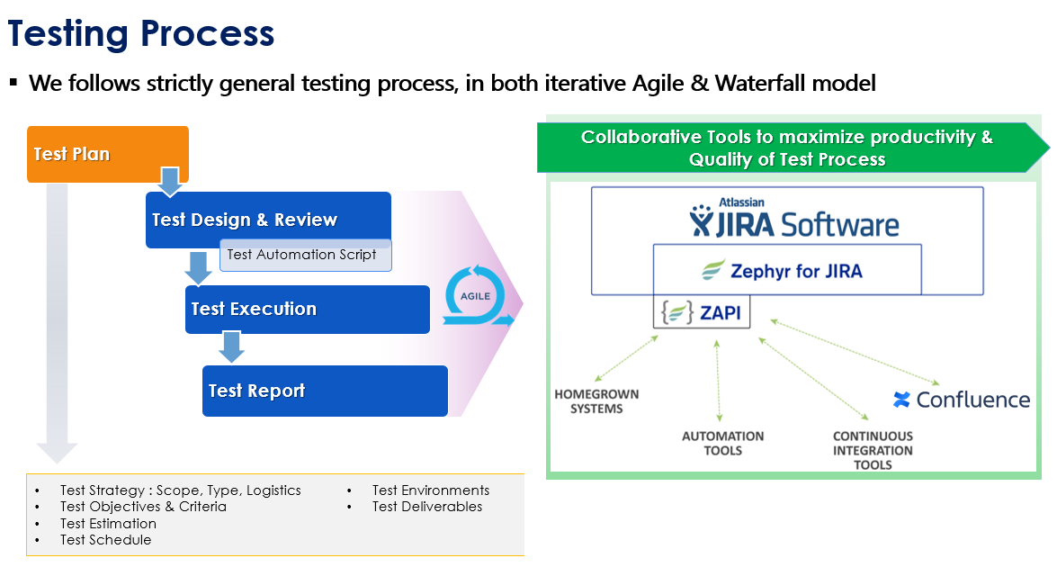

* 1. *Automation strategy*

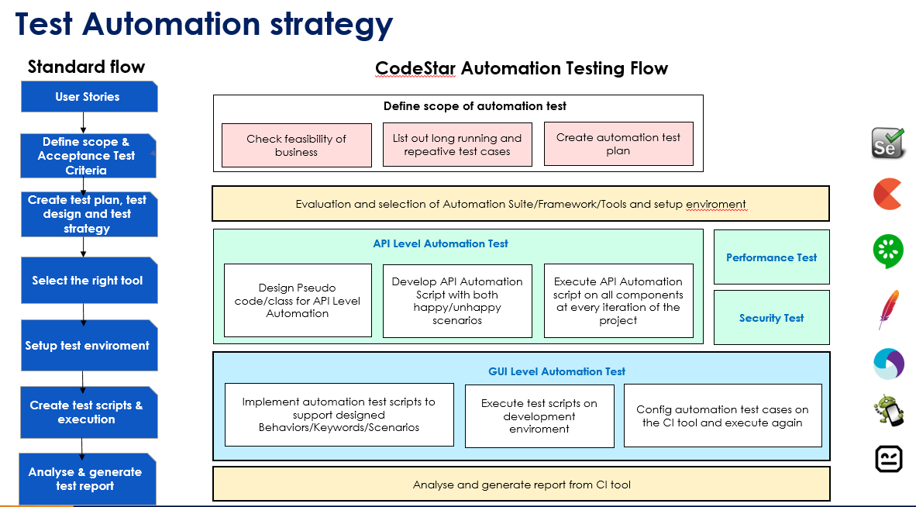

* 1. *Automation testing framework*

**Framework library/ tools:**

* Maven
* TestNG
* Github
* Selenium

**Language**:

* Java
* Python
* C#
* Javascript

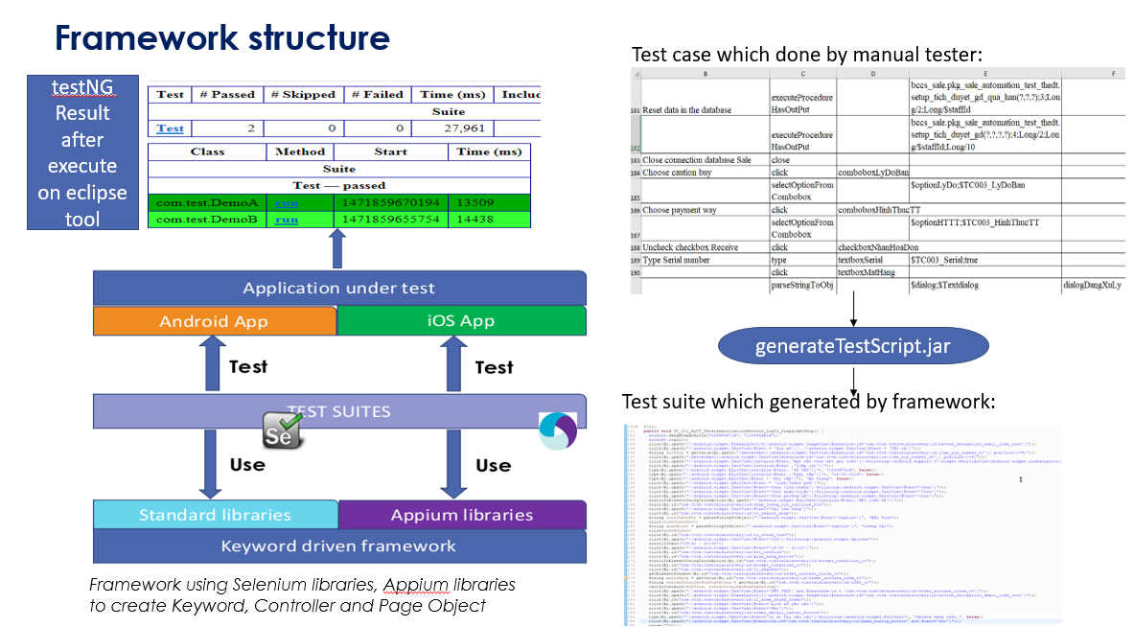

1. **LIFECYCLE OF BUG AND RISK**

BUG LIFECYCLE

